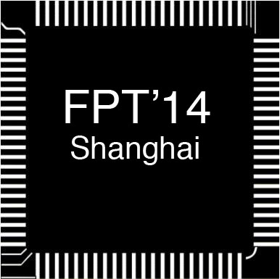
ICFPT 2014

The 2014 International Conference
on Field-Programmable Technology
Parkyard Hotel
Dec. 10-12, 2014 Shanghai, China
http://www.icfpt2014.org

Dear Sir and Madam:

We are going to reserve the ZTE Hotel for you during the conference for ICFPT 2014. The room rate is RMB 480 (about USD80)/per room per night with breakfasts. Please confirm how many nights you will stay at the hotel before November 20, 2014. The payment for the hotel has to be settled before November 20, 2014. Please send your confirmation via email or fax reply. The payment for hotels should be paid directly to the conference cooperator- Shanghai Xinmei Conference Service Co., Ltd.

Note: Please send the bank documents information back to us after your payment is settled.

Information of ZTE Hotel is as follows:

ZTE Hotel, Shanghai, China
Address：866 Keyuan Road, Pudong Shanghai China
Zip: 201203
Tel: +86-21-51333666
Website: www.ztehotel.com

The Hotel Booking Form is as follows, please fill it out and send it back to us by Email or Fax（Email: shirley@xinmeics.com; Fax: +86-21-64692062）

Hotel Booking Form for Participants
Guest Information ( please tick √ )
Check-in Date | Date Month |  | Checkout Date |  |  | Date Month |  |  | Total nights
Name |  |  | Title |  |  |  | Sex |  | Male |  | Female
Company or University
Address
Telephone No. |  | Cell Phone |  |  |  |  |  | Fax
Room Type | double room |  |  |  | RMB480/per night
Other Special Request
Payment Method | In order to guarantee the rooms booking, full payment must be settled before 20, Nov., 2014 (the payment fee couldn’t be deducted by bank in the room rate)  ■ Payment by bank transfer  Account Name: Shanghai Xinmei Conference Service Co., Ltd.  Account Number: 31691303001832394  Opening Bank: Bank of Shanghai Caoxi Sub-branch  SWIFT BIC: BOSHCNSH  Address Of Bank: No.11 Puhuitang Road, Shanghai, P. R. China  - Payment by post office  Payee: Shanghai Xinmei Conference Service Co., Ltd.  Address: Room 301, No.46 Puhuitang Road, Shanghai 200030, P. R. China
Contact Tel: +86-21-64280263；Fax: +86-21-64692062
Contact Persons: Ms. Shirley Hu, cell phone: +86-18917192814
Email：shirley@xinmeics.com
Shanghai Xinmei Conference Service Co., Ltd.

