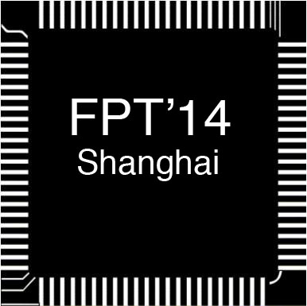
ICFPT 2014
Registration Form
The 2014 International Conference
on Field-Programmable Technology
Parkyard Hotel
No.699 Bibo Road, Pudong, Shanghai
Dec. 10-12, 2014 Shanghai, China
http://www.icfpt2014.org
Jiting Sheng
School of Microelectronics, Fudan University
220 Handan Road, Shanghai 200433, China
Email: fpt2014@fudan.edu.cn; Tel: +8621 65643761; Fax: +8621 65643449

Payment by Credit Card, Bank Transfer, or Check

1. Participant: Accepted Paper ID Number（if available）:
□ Mr. □ Ms. □Other: First Name: Last Name:

Affiliation (Univ./Company):
Address:
Division:
Phone: Fax: Email:

2. Registration Fee
Classification | Before Nov.7, 2014 | After Nov.7, 2014 | Amount
IEEE member★ | □ 3500 CNY | □ 3800 CNY
Non-member | □ 3800 CNY | □ 4100 CNY
Student | □ 2400 CNY | □ 2700 CNY
Extra banquet ticket | □ 300 CNY
□ Vegetarian | □ Need hardcopy Proceedings 400 CNY  □ Don’t need hardcopy Proceedings
□ Workshop 1★★ | “Zynq Lab in a box” by Xilinx, Dec. 9 |  | Free
□ Workshop 2★★ | “Introduction of SoC FPGA using DE1-SOC kit”by Altera, Dec. 9 |  | Free
□ Workshop 3★★ | “ARM PSoC 4 Lab-in-a-box” and “Bluetooth Low Energy Workshop” by Cypress, Dec. 13 |  | Free
□ Workshop 4★★ | “OpenCV Application Acceleration with Vivado High Level Synthesis” by Xilinx, Dec. 13-14 |  | Free

(★IEEE Member) ★ Member Number: __________________________
★★ Workshop details are provided in ICFPT2014 webpage. If you want to participate in any workshops listed above, please check the correspondent checkboxes.
The registration fee covers:
- Admission to all the sessions;
- Three days’ lunches (Dec. 10-12, 2014) plus the reception (Evening of Dec. 10) and the banquet (Evening of Dec.11); Coffee Breaks;
- A conference kit (with a conference bag, a program brochure, and a USB with E-Proceedings).

3. Payment Methods

1) □ Bank Transfer  (For attendees outside Mainland China)  Remit date____________  Note: If it is not possible for you to transfer CNY, please transfer USD based on the USD/CNY exchange rate of the day of transfer. | Sender’s Name_________________  Account Name: Fudan University  Account Number: 437759252978  Bank Name: 044159 Bank of China Shanghai Guo Ding Road Sub-Branch  Bank address: No.288, Guo Ding Rd.. Shanghai, 200433， China  Swift Code: BK CH CN BJ 300  Attn:ICFPT 2014 | ______ CNY
2) □ Bank Transfer  (For attendees from Mainland China)  Remit date____________ | 开户银行：上海 农行五角场支行营业部  户名: 复旦大学  帐号: 033267－08017003441 | ______ CNY
3) □ Bank Draft/Check  Remit date____________ | I have enclosed herewith a bank draft/check made payable to Fudan University and sent to Huihua Yu | ______ CNY

Please send the Registration Form and Payment Receipt to Jiting Sheng by Email or Fax

Email: fpt2014@fudan.edu.cn
Fax: +86-21-65643449
Mailing address: Department of Microelectronics, Fudan University,
220 Handan Road, Shanghai, 200433, China

4. Comments

PERSONAL INFORMATION PROTECTION LAW:
In consideration of personal information protection law in China, your personal information is applied to limited purposes listed below.
- Used only for the things relevant to ICFPT2014
- Correspondence between participants and the Conference Committee/Secretariat

